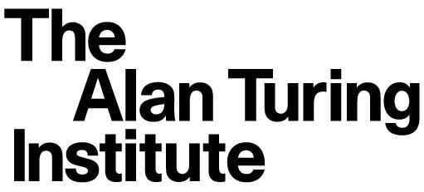
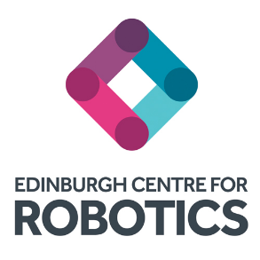

UK-Japan Robotics and AI research collaboration workshop
17-18 September 2019

Agenda
Informatics G.07 and Atrium, University of Edinburgh

17 September 2019

10:00 – 12:00 Registration
Poster session (all participants)

12:00 - 13:00 Lunch

13:00 - 13:30 Introduction to Edinburgh Centre for Robotics, The Alan Turing Institute and Bayes Centre
- Professor Sethu Vijayakumar (Edinburgh Centre for Robotics and The Alan Turing Institute)
- Cristian Novotny (Bayes Centre)

13:30 - 13:50 RIKEN presentation - Professor Masashi Sugiyama

13:50 - 14:10 AIST presentation - Dr. Yoshiki Seo

14:10 - 14:30 NII presentation - Dr. Emmanuel Planas

14:30 - 15:00 Coffee break

15:00 - 17:00 Topics of interest related to the workshop themes
Selected participants spotlight presentations

17:00 - 18:00 Edinburgh Centre for Robotics lab tour

18:30 - 21:00 Dinner Playfair Library
- Introduction: Professor Sethu Vijayakumar, Programme Director for AI, The Alan Turing Institute
- Welcome speech: Professor Dave Robertson, Head of College of Science & Engineering
- Dinner keynote: Professor David Lane, Centre Director, Edinburgh Centre for Robotics
- Closing speech: Professor Jane Hillston, Head of School, Informatics

18 September 2019

9:00 - 9:30 Pastries and coffee

9:30 – 11:00 Discussion and agreement on topics/challenges of interest
Participants to select one of the three themes/breakout groups

11:00 - 11:30 Agreement on long-term core research topics (low TRL)

11:30 - 12:00 Agreement on industry focused research (high TRL)

12:00 - 13:00 Lunch
-------------------------------------------------------------------------------------

13:00 RIKEN and Edinburgh Data Science & Machine Learning
session (attendance optional)

13:00 - 15:40 Oral talks
- Yasuo Tabei (RIKEN)
- Taku Komura (University of Edinburgh)
- Emtiyaz Khan (RIKEN)
- Michael Herrmann (University of Edinburgh)
- Tatsuya Harada (RIKEN)
- Michael Gutmann (University of Edinburgh)
- Mastoshi Hamanaka (RIKEN)
- Robert Fisher (University of Edinburgh)

15:40 - 16:00 Coffee break

16:00 - 18:40 Oral talks
- Qibin Zhao (RIKEN)
- Iain Murray (University of Edinburgh)
- Kohei Hatano (RIKEN)
- Stefano Albrecht (University of Edinburgh)
- Takanori Maehara (RIKEN)
- Michael Mistry (University of Edinburgh)
- Ha Quang Minh (RIKEN)

18:40 Dinner

19:30 Close

UK-JAPAN robotics and AI research collaboration workshop

Professor Sethu Vijayakumar has been recently announced as Programme Co-Director for Robotics and Artificial Intelligence (RAI) at The Alan Turing Institute. The Turing RAI hub is based at the University of Edinburgh where the workshop will take place.

The Alan Turing Institute, the UK’s national institute for data science and artificial intelligence, has initiated agreements with AIST (the National Institute of Advanced Industrial Science and Technology), one of the largest research institutes in Japan focusing on bridging the gap between research ideas and commercialisation, NII (National Institute of Informatics), an inter-university academic research institute working to advance research and development in informatics-related fields and the RIKEN Center for Advanced Intelligence Project , funded by the Japanese government to advance AI technologies and explore their ethical, legal and social impact.

The Turing's collaborative agreements with Japan are part of a wider UK government
announcement relating to new scientific collaborations between UK and Japan in the fields of robotics, AI and the ethical use of data.

Joint activities between the Turing and the three organisations will include researcher exchange placements, developing joint proposals for academic low-Technology Readiness Levels (TRL) research as well as industry-driven high-TRL research. There will also be networking and knowledge exchange activities.

This is the first workshop to identify the collaboration topics and as such a very important first step to create concreate outcomes from the signed agreements and MoUs. Following this workshop in Edinburgh there will be an Industry workshop at The Turing, London to align the high-TRL research focus with industry interest. One of the main objectives of the Industry-focused research is to get companies to support research on robotics and AI.

The proposed 3 key themes for the workshop are:
● Scalable algorithms under constraints
● Methods for efficient multi-agent computations
● Verifiable, robust and explainable decision making for multimodal RAS assets
It would be great if all participants prepare two slides for discussion about their research interest and if they propose any other themes for the research topics.

The expected outcomes of the Edinburgh workshop are:
● List of research topics grouped around key themes and lead PIs
● Agreement on Industry focused research (high TRL)
● Agreement on long-term core research topics (low TRL)
● Research exchange mechanisms
o Short-term Internships
o UK and Japanese Government backed Research Funds

