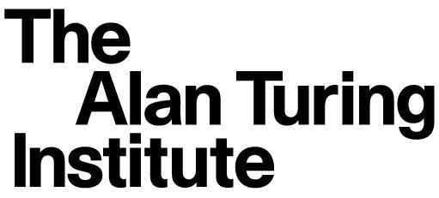

UK-Japan robotics and AI research collaboration workshop
19 September 2019

Agenda

The British Library
96 Euston Road
NW1 2DB, UK
The Alan Turing Institute is located on the first floor of the British Library and can be accessed via the main doors from 9:30 onwards. Please allow 10 minutes for queuing when planning your journey.

11:30 - 12:30 Registration and lunch

12:30 - 13:00 The Alan Turing Institute’s presentation
Professor Sir Adrian Smith

13:00 - 16:00 Research topics for industrial collaboration
Professor Sethu Vijayakumar to summarise high TRL level
research topics.
Industry and Academia Research Carousel

16:00 - 16:30 Summary of agreed industrial research collaboration

16:30 Bus transport to Japanese Embassy

17:30 - 19:30 Networking event at Japanese Embassy of Japan:
101-104 Piccadilly
London W1J 7JT

UK-JAPAN robotics and AI research collaboration workshop

Professor Sethu Vijayakumar has been recently announced as Programme Co-Director for Robotics and Artificial Intelligence (RAI) at The Alan Turing Institute (ATI). The ATI RAI hub is based at the University of Edinburgh where the workshop will take place.

The Alan Turing Institute (ATI), the UK’s national institute for data science and artificial intelligence, has initiated agreements with AIST (the National Institute of Advanced Industrial Science and Technology), one of the largest research institutes in Japan focusing on bridging the gap between research ideas and commercialisation, NII (National Institute of Informatics), an inter-university academic research institute working to advance research and development in informatics-related fields and the RIKEN Center for Advanced Intelligence Project , funded by the Japanese government to advance AI technologies and explore their ethical, legal and social impact.

The Turing's collaborative agreements with Japan are part of a wider UK government
announcement relating to new scientific collaborations between UK and Japan in the fields of robotics, AI and the ethical use of data.

Joint activities between the Turing and the three organisations will include researcher exchange placements, developing joint proposals for academic low-Technology Readiness Levels (TRL) research as well as industry-driven high-TRL research. There will also be networking and knowledge exchange activities.

This is the first workshop to identify the collaboration topics and as such a very important first step to create concreate outcomes from the signed agreements and MoUs. Following this workshop in Edinburgh there will be an Industry workshop at ATI, London to align the high-TRL research focus with industry interest. One of the main objectives of the Industry-focused research is to get companies to support research on Robotics and AI.

The proposed 3 key themes for the workshop are:
● Scalable Algorithms under Constraints
● Methods for efficient multi-agent computations
● Verifiable, Robust and Explainable decision making for multimodal RAS assets
It would be great if all participants prepare two slides for discussion about their research interest and if they propose any other themes for the research topics.

The expected outcomes of the workshop are:
● List of research topics grouped around key themes and lead PIs
● Agreement on Industry focused research (high TRL)
● Agreement on long-term Core Research Topics (low TRL)
● Research Exchange Mechanisms
o Short-term Internships
o UK and Japanese Government backed Research Funds

