

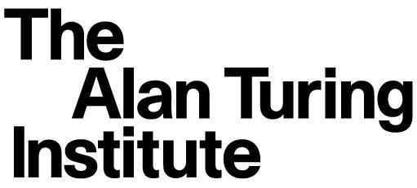 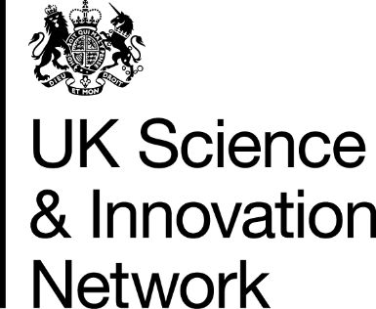

**UK-Italy robotics and AI research collaboration workshop**

18-19 March 2020

Venue:

Villa Wolkonsky

Via Ludovico di Savoia, 11

00185 Roma RM,

Italy

**Agenda**

**Wednesday 18 March 2020**

**10:00 – 12:00 Registration**

**Poster Session (all participants)**

**12:00 – 13:00 Lunch**

**13:00 – 13:15 Welcome address**

*Eleanor Sanders, Minister and Deputy Head of Mission, British Embassy in Rome*

**13:15 – 13:30 Introduction to the workshop**

*Professor Angelo Cangelosi*

**13:30 – 13:45 CINI-AIIS presentation**

*Professor Rita Cucchiara*

**13:45 – 14:00 Artes 4.0 Presentation**

*Professor Paolo Dario*

**14:00 – 14:15** **IIT Presentation**

*Dr Danielle Pucci*

**14:15 – 14:45 Keynote: The Turing at the forefront of shaping the UK Robotics and AI agenda**

*Professor Sethu Vijayakumar*

**14:45 – 15:15 Coffee Break**

**15:15 – 15:45 Keynote: Professor Antonio Chella and Professor Daniele Nardi**

**15:45 – 17:30 Short Talks**

**18:00 – 20:30 Dinner**

**Thursday 19 March 2020**

**09:00 – 09:30 Pastries and coffee**

**09:30 – 10:00 Keynote: Professor Giorgio Metta**

**10:00 – 10:15 Introduction to discussion groups**

**10:15 – 12:30 Parallel Groups Discussion**

**12:30 – 13:30 Lunch**

**13:30 – 14:30 Report from Parallel Groups**

**14:30 – 17:00 General Discussion**