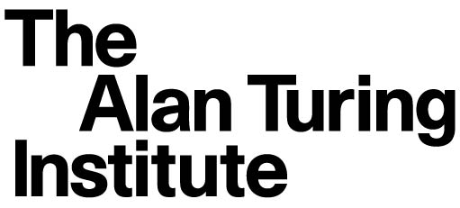

Complexity and token economy
12 February 2020
Agenda

City, University of London
Northampton Square, EC1V 0HB
Taking place in the Oliver Thompson Lecture Theatre, located in the Tait Building and can be accessed through the University Building in Northampton Square.

14:00 - 14:20 Welcome – Andrea Baronchelli (Reader at City Uni. London, Economic Data Science theme lead at The Alan Turing Institute)

14:20 – 14:50 Finding the token economy in on-chain data – Philip Gradwell (Chief Economist at Chainalysis)

14:50 – 15:20 Title TBA - Lex Sokolin (Global Fintech Co-Head at ConsenSys)

15:20 – 15:50 Regulatory considerations for the Token Economy – Keith Bear (Cambridge Centre for Alternative Finance)

15:50 – 16:30 Coffee break

16:30 – 17:00 Collective dynamics of dark web marketplaces – Abeer Elbahrawy (Data Scientist at City and Chainalysis)

17:00 - 17:30 Decentralizing platforms economics: Incentives and structures – Simone Righi (Lecturer in Financial Computing at UCL)

17:30 – 18:00 Token engineering: Data science meets mechanism design – Michael Zargham (Founder and CEO at BlockScience)

18:00 Pub

