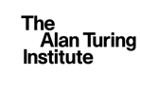

Structured Missingness: Call specification and Guidance to secondment applicants

Contents
Background 2
Terms and conditions 3
Eligibility 3
How to apply 3
Funding available 4
Review process 5
Summary of key dates 6
Offer Acceptance Process 6
Post Award information 6
Queries 7
Our Values 8
Flexigrant Application: Structured Missingness Project Proposal 9
ANNEX 2: Approval of publications procedure: 11

Background

The Turing health and medical sciences programme has long-term interests in personalised healthcare and treatment heterogeneity – the analysis of how medical treatments can affect different people in different ways. The programme is seeking to generate insights which improve the understanding of patient and disease heterogeneity and its relevance to clinical outcomes.
The Turing has a strategic partnership with Roche. The goal of this partnership is to establish a world-leading collaboration in advanced analytics between Roche and the Turing, focused on enabling the transformative benefits of personalised healthcare to become a reality for patients around the world. Publication of methods and algorithms will follow the principles of open science to ensure that they are reproducible and interoperable.
Further information about the partnership, including a short video from the kick-off event earlier this year, can be found on our dedicated project page here.
We recently hosted three Structured Missingness workshops, which encouraged and facilitated strong collaboration, a key pillar of how we foresee awarded projects working. The workshops convened a community of researchers interested in developing new tools and methods to learn from heterogeneous data with structured patterns of missing data. The intention of these events was to bring a diverse community of researchers together ahead of opening this call– including established and early career researchers – to seek synergies and develop collaborative project ideas.
Successful applicants will have access to and be able to use the Roche Clinico-Genomic Database, that combines real-world patient level clinical data with in-depth genomic profiling for over 30,000 patients. While this data set is enormously rich, it also possesses significant structured missingness: the sets of genes measured varies between patients depending upon which tests they received; similarly, the clinical measurements vary between patients depending upon their particular indication. The objective of the workshop was to scope out approaches to Structural Missing Data, particularly using the Clinico-Genomic Database as motivation, and formulate substantive research questions that merit further exploration.
Stemming from the workshop we are now inviting applications for proposals of projects that address Structured Missingness. This call invites project ideas that have been generated through the collaborative discussions, networking, and co-creation of project ideas using the whiteboarding platform during the workshops, as well as proposals from those who did not attend the workshops.
Please note that you are able to apply even if you did not attend the workshops but please be aware collaboration is key throughout the project lifecycle. Each project team seconded under the Structured Missingness workstream will be expected to communicate with one another through meetings such as knowledge shares, as well as work with the Partnership Community Manager to engage with one another and to actively collaborate with Roche researchers in this area. In addition, project teams are expected to all communicate and collaborate asynchronously e.g., via Slack discussions.
Submissions for applications will open on the 8 December 2021 and will remain open until the submission deadline: 31 January 2022 12:00pm GMT (midday).
If you were involved in the workshops ahead of the open call you will continue to have access to the whiteboard and networking space that you used to co-create your ideas in your groups to aid you in putting your application together.

Terms and conditions

Successful applicants and their teams (as applicable) will be engaged via a secondment agreement to Turing, which must be signed prior to the project starting, subject to the agreement of your employer and subject to any applicable UK visa requirements. Data access will also not be granted until secondments are signed.
- This funding is flowed down from Turing’s strategic partnership with Roche, which forms an important element of total funding for Turing’s work on Treatment Heterogeneity.
- The funding will be contracted via a secondment agreement aligned to the IP terms below.
- Within this partnership, both Turing and Roche are committed to sharing algorithms and methods publicly.
- We anticipate that all project IP will be jointly owned by Turing and Roche. The intention is that all IP will be published on an open-source basis under a creative commons license.
- When project teams are ready to publish results (which may include, but is not limited to, journal articles, code, conference presentations) there will be an approval procedure to follow. See “approvals of publications procedure” in Annex 2 for details.

Eligibility

To be eligible to apply you must:
- Be part of a university or research institute. Commercial organisations are not eligible.
- Have permission from your organisation to apply, i.e., ensure your organisation agrees to the Terms and Conditions above and that you submit an approval of submission letter from your research/finance office stating this. Please submit one letter per university. [14/01 update – please note we previously stated that a letter of support from Head of Department AND from the research/finance office is required, in order to reduce the administrative burden this is no longer the case].

How to apply

- Applications must be submitted via the online portal at https://ati.flexigrant.com/. If you have not already done so, all applicants must first register on the system and provide basic details to create a profile. If you have any questions regarding the application form or using the online system, please contact the health programme inbox healthprogramme@turing.ac.uk
- Please use the budget template provided in the Flexigrant application form (page 2). Please note, applicants will need to upload with the application form on FlexiGrant an approval of submission letter from your research/finance office to confirm costs are correct and that the university will be willing to second the team members to Turing, including the terms outlined above. The Principal Investigator must ensure the same is received for all universities on multi party applications.
- See Annex 1 for the full application form that will be available on FlexiGrant.

Funding available

Please note that due to the header terms attached to this partnership, these secondment details are an exception to the usual Turing overhead model for secondments for this call only.
The model laid out below will require approval from the Principal Investigator’s and collaborators’ Head of Department and administration teams – please ensure approval is obtained as early as possible.
- We anticipate project length to range from 6 to 18 months.
- 100% salary and on-costs will be paid to the university.
- Overheads should be calculated at the Turing rate of £65,000 per FTE per year, 50% of which will be recoverable by the university. [14/01 N.B This is hard coded into the finance template, you do not need to add this yourselves]
- 20% VAT is applicable to these secondments.
- Eligible costs include:
  - Salary of personnel working directly on the project – this could include, for example, PIs, postdoctoral research associates, research assistants, data managers, data scientists or software engineers.
  - travel and subsistence for project researchers (e.g., attending conferences, travelling to/from the Turing/other collaborators)
  - conference or event attendance fees (where conference/event is directly applicable to the research project)
  - Cloud computing or other high performance computing costs.
  - Other costs which are specifically justified for the project e.g., books, meeting room or catering costs, specific laptops (laptops will be provided by Turing for researchers 100% FTE seconded to Turing and do not need to be costed in)
  - Open access publications.

Please note, the budget requested may not be funded to the maximum requested amount. Reviewers/leads may work with applicants to build collaborative projects which may involve updating costs for projects.

As secondees, researchers can request to receive access passes to use the Turing office space and meeting rooms.

Review process

Applications will be reviewed by Scientific Leads Alisha Davies (Turing), Ben MacArthur (Turing), Chris Harbron (Roche), and Ryan Copping (Roche) and scored according to the selection criteria. (Please declare any conflict of interest in your application form.).
Step-by-step review process
- Basic eligibility check by Research Project Manager
- All eligible applications undergo individual review and scoring by review panel members
- Panel meeting to discuss all applications and individual scores. Final outcomes decided (Outcomes may be unsuccessful or successful)
  - Outcomes of “revise and resubmit” will be provided feedback and the option of discussion meeting with a designated project member in order to revise the proposal and resubmit on FlexiGrant
- After resubmission, the panel will reconvene and make final decisions on resubmitted applications.
Selection Criteria

- Scientific Novelty & Timeliness
  - Describe which element(s) of your project are novel, how it includes new method(s) or new observation(s) that lead to new knowledge discovery and how it contributes to scientific progress.
  - Describe how your project is addressing the contemporary challenges faced in data science for healthcare, in particular structured missingness.
- Feasibility
  - Describe how easily (or conveniently) your proposed idea can be implemented.
- Attainability
  - Describe, as best you can, the attainability of your project
- Level of contribution towards the Partnership’s “North Star” of understanding patient and disease heterogeneity
  - Provide detail on how your project idea contributes towards achieving the Partnership’s North Star. For example, how will your idea change/attain/expedite/significantly contribute to the pathway to understanding patient and disease heterogeneity?
- Utilising the Partnership & Benefit of your collaborative team
  - Describe how your project benefits from both the Turing’s position as a National Institute and Roche that could not have been addressed within a single academic institution otherwise. What is the added value of the combined expertise of the co-investigators?
- Value for money
  - Clearly define and justify resources requested to carry out the proposal. Describe how they are appropriate given the scope of the project.
The Panel will be chaired by Chris Holmes (Turing).
After the submission deadline (31 January 2022), eligibility checks will be undertaken and completed by 2 February 2022. The reviewing panel members will complete individual proposal reviews by the end of 18 February 2022. The reviewing panel members will convene 4 March 2022 to make final decisions as to the outcome of the submitted proposals. Final decisions (successful or unsuccessful) will be communicated, with feedback, via email by the end of 11 March 2022.
The offer acceptance deadline will be end of 30 April 2022, with secondments to be signed by end of 30 April 2022. Projects are anticipated to start by June 2022 with all projects anticipated to be fully completed, with reports submitted, by December 2023.

Summary of key dates

Workshop dates | 10 November 2021, 17 November 2021, 1 December 2021
Publication of call for proposals | 8 December 2021
Q&A Session | 12 January 2022
Deadline for proposals | 31 January 2022, 12:00 pm GMT (midday)
Eligibility checking | 2 February 2022
Individual panel member proposal reviews | 18 February 2022
Panel members convene to make final outcomes decision | 4 March 2022
Final decision outcome communication by | 11 March 2022
Offer Acceptance Deadline | 30 April 2022
Secondments signed by | 30 April 2022
Projects start by | June 2022
Projects to complete and report by | December 2023

Offer Acceptance Process

Successful applicants will be notified via an email. An offer along with the Turing secondment agreement template will be sent for their organisation to review.
The offer will be open for a period of fifty (50) calendar days from the Offer Date. In order to benefit from the offer, successful applicants will have to do the following:
A) Respond to the email on whether you accept the offer
B) Sign Secondment agreement
C) Sign the Project Start Confirmation Form
The offer will lapse if secondment agreements are not signed by the end of 19 April 2022. The funding will subsequently be reallocated to other projects in due course.

Post Award information

Awarded projects and therefore the seconded project teams will form the Structured Missingness workstream of The Turing-Roche partnership. This is the first workstream to be funded, however it is anticipated there will be many more throughout the partnership lifespan.
Collaboration and engagement are critical to the successful delivery of the entire workstream. It is therefore expected that secondees will be active members of the wider workstream, the partnership, and The Turing more broadly. They will be given opportunities to communicate technical topics, both orally and in writing, to colleagues and external partners, for example, by preparing and presenting reports, blog posts, organising and delivering presentations, and taking an active role in regular meetings and discussions.
Each project will be expected to complete short project updates in a predefined format each quarter, in addition, a comprehensive final report outlining the project aims, achievements, research is expected.
Prior to the start of secondments, you will be asked to complete a Background IP register to log any IP you propose to bring to the project, which will be reviewed by Roche and Turing Leads.

Queries

Should you have any queries, please contact healthprogramme@turing.ac.uk. Please note, this inbox will not be monitored during the Christmas break whilst the Institute is closed (24 December 2021 – 3 January 2022 inclusive).

Our Values

The Alan Turing Institute is committed to equality diversity and inclusion and to eliminating discrimination. All employees and secondees are expected to embrace, follow and promote our EDI Principles and Our Values.

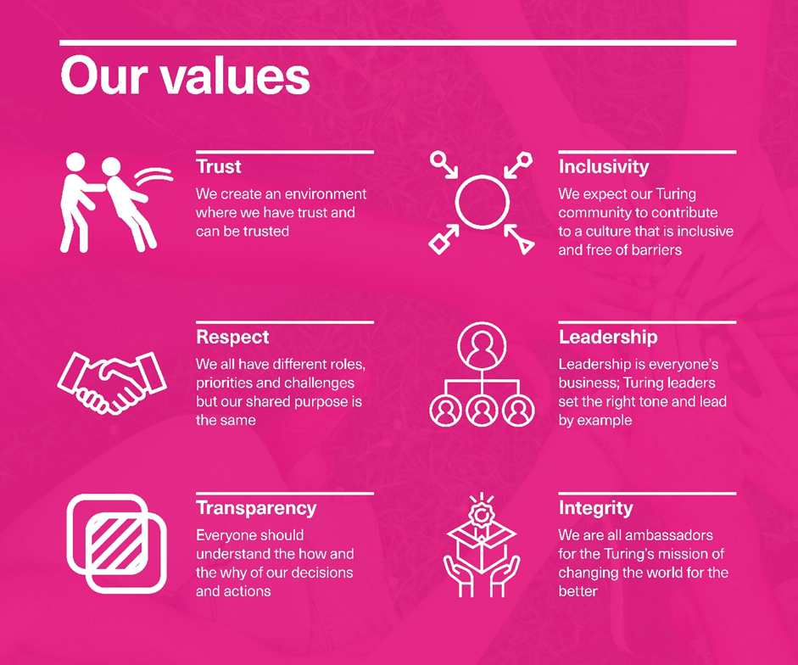

ANNEX 1: For reference: online form content

Flexigrant Application: Structured Missingness Project Proposal

Page 1: Lead Applicants Details
Title
First Name
Surname
Organisation
Role
Email Address
Phone Number
CV upload (max 2xA4 pages)
Page 1: Co-Applicant(s) Details
Title
First Name
Surname
Organisation
Role
Email Address
Phone Number
CV upload (max 2xA4 pages)
Page 2: Project Details
Project title 100 words max
Project details: Please populate the relevant sections with your project proposal
- Abstract (250 words)
- Outline of research question and scientific approach (800 words)
- If you are using the clinico-genomic database, how are you anticipating using it? Or if you are using a different database, what data will be used (if any) and what legal and ethical approval (if relevant) is required to allow the team access? (500 words)
- Impact of your project (200 words)
- Relevance of your project to the partnership’s ‘North Star’ (200 words)
- Describe any collaborative practices for co-creation in design and/or delivery with other funded projects in the Structured Missingness workstream (200 words)
- Data readiness (200 words)
  - Does the research team have, or have a plan for, access to any datasets and/or facilities essential to the quick commencement and ultimate success of the project? Does the team have an alternative data source, open data set, or synthetic data set, which could be used for the research if the originally planned data sources are not accessible?
- Project Outputs and Deliverables (300 words)
- Risks to Project Delivery and Mitigations (300 words)
- Proposed budget (upload excel file for costs) & justifications of costs (300 words)
- Team's roles and expertise (200 words)
- References (free text, do not contribute to word count)
Page 3: Eligibility
Please confirm your eligibility below
I confirm that I am employed by a UK university (not limited to the Turing university partner network).
I confirm that the appropriate permissions are in place to allow the project to be undertaken under the terms outlined in the call, should this application be successful.
Please upload a PDF approval to submit letter from your Finance / Research support office (to confirm costs are correct and that the university will be willing to host and accept the secondment, including the terms outlined above). Also, please obtain the same for all universities on multiparty applications (Upload document box.)
Please declare any conflict of interest here: (Free text box here)

ANNEX 2: Approval of publications procedure:
- A proposed publication shall be submitted to the Reviewing Party prior to submission in order to be able to make comments on the Publishing party’s proposed publications
- Comments will be provided within 30 days
- All reasonable comments will be incorporated (unless the changes will adversely compromise the science)
- No confidential or non-public IP will be contained in the proposed publication, without prior written consent
- The Reviewing Party can request a 90-day delay to submission to publish, which may include reasonable additional delay requests to prevent IP or confidential information being compromised or lost

